**DECLARATION**

I/Wehereby declare that this project work entitled **<School Management System>** is a record done by us.

I also declare that the matter embodied in this project is genuine work done by us.

Place : Rajkot

Date : 1st December 2024

**Student Name-1 - Ayush Majithiya**

**Student Name-2 - Tej Shah**

**CONTENTS**

|  |  |  |
| --- | --- | --- |
| **Chapters** | **Particulars** | **Page No.** |
| **1** | **Introduction** |  |
| **2**  2.1  2.2 | **PREAMBLE**  Project overview  System requirements |  |
| **3** | **FEATURES** |  |
| **4**  4.1 | **TECHNICAL DESCRIPTION**  Model description |  |
| **5**  5.1  5.2  5.2.1  5.3  5.3.1  5.3.2  5.3.3  5.4 | **SYSTEM DESIGN AND DEVELOPMENT**  **(Only applicable diagrams)**  **Architectural Design**   * Class Diagram   **Dynamic Modeling**   * Use Case Diagram * Sequence Diagram * Activity Diagram * Any other applicable diagram (applicable)   Database Design (If applicable) |  |
| **6** | **Implementation details** |  |
| **7** | **Testing and future enhancement** |  |
| **8** | **conclusion** |  |

# School Management System

## Documentation

## Table of Contents

* Introduction
* Project Overview
* System Requirements
* Features
* Modules Description
* Diagrams and Flowcharts
  + Use Case Diagram
  + Data Flow Diagram
  + Entity-Relationship Diagram
* Database Design
* Implementation Details
* Testing
* Limitations and Future Enhancements
* Conclusion

## 1. Introduction

The School Management System is a web-based application designed to simplify school administration tasks. Built using PHP Laravel, it enables effective management of students, teachers, classes, attendance, and academic records, fostering transparency and efficiency.

## 2. Project Overview

This project provides a structured interface for managing school operations with the following user roles:  
1. Admin: Oversees and manages all data.  
2. Teachers: Updates attendance and grades.  
3. Students: Tracks personal academic details.  
4. Parents: Monitors their child’s performance  
  
The system ensures secure access and organizes data through a centralized platform.

## 3. System Requirements

Software Requirements:  
- PHP (7.2 or higher)  
- Laravel Framework  
- MySQL Database  
- Apache Server or XAMPP  
  
Hardware Requirements:  
- Processor: 2.0 GHz Dual-Core or better  
- RAM: 4 GB or higher  
- Storage: At least 1 GB

## 4. Features

1. User Authentication: Role-based access for admin, teachers, students, and parents.  
2. Student Management: Record student details like grades and attendance.  
3. Teacher Management: Assign classes and subjects to teachers.  
4. Class Scheduling: Organize classes and assign subjects.  
5. Attendance Management: Track attendance records daily.  
6. Reports Generation: Summarize academic and attendance data.  
7. Parent Monitoring: Inform parents about their child’s progress.

Other features are:

* Admin Panel
* Students Panel
* Teachers Panel
* Parents Panel
* Teacher Management
* Subject Management
* Class Management
* Student Management
* Parents Management
* Manage Student Attendance
* Attendance Report
* Assign User Roles
* Update User Profile

## 5. Modules Description

Admin Module:  
- Manages core school operations like adding and updating students, teachers, and classes.  
- Assigns roles and sets up schedules.  
  
Teacher Module:  
- Facilitates attendance marking and grading.  
- Provides access to assigned subjects and classes.  
  
Student Module:  
- Offers details on grades, attendance, and schedules.  
  
Parent Module:  
- Ensures parents stay updated with their child’s academic progress.

## 6. Diagrams and Flowcharts

This section will include diagrams:  
- Use Case Diagram: A diagram showing interactions between user roles and system functionalities.

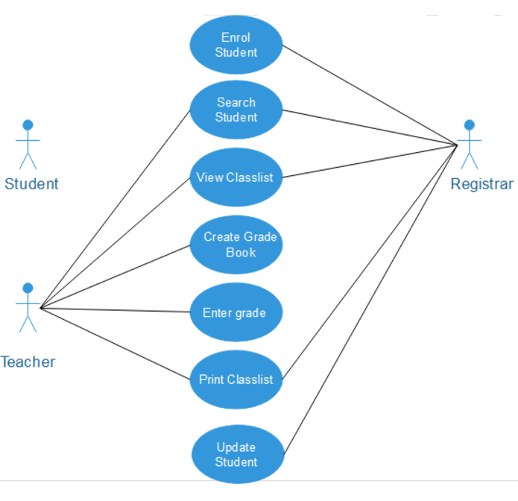

- Data Flow Diagram: Level 0 and Level 1 DFD describing the flow of data.

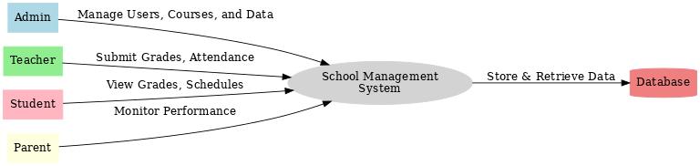

- Entity-Relationship Diagram: Shows relationships between entities such as Users, Classes, Students, etc

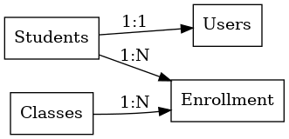

## 7. Database Design

Key Tables:  
1. Users: Stores login credentials and role assignments.  
2. Students: Contains student-specific data.  
3. Teachers: Stores teacher details.  
4. Classes: Organizes classes and schedules.  
5. Attendance: Tracks daily attendance records.

## 8. Implementation Details

Technologies Used:  
- Backend: PHP (Laravel Framework)  
- Frontend: HTML, CSS, Bootstrap  
- Database: MySQL

## 9. Testing

Types of Testing Conducted:  
1. Unit Testing: Verified individual modules like attendance management.  
2. Integration Testing: Tested interactions between modules (e.g., Teacher and Attendance modules).  
3. System Testing: Ensured the entire system functions as intended.  
  
Sample Test Cases:  
| Test Case ID | Test Description | Expected Outcome | Status |  
|--------------|--------------------------|----------------------------------|----------|  
| TC-01 | Login validation | User is redirected to dashboard | Passed |  
| TC-02 | Add new student | Student record is saved | Passed |  
| TC-03 | Generate attendance report | Report generated successfully | Passed |

## 10. Limitations and Future Enhancements

Limitations:  
- Lack of automated notifications for attendance updates.  
- No dedicated mobile application.  
  
Future Enhancements:  
1. Integrating SMS and email notifications.  
2. Enhancing the analytics dashboard for trend insights.  
3. Building a mobile app for better accessibility.

## 11. Conclusion

The School Management System is an efficient tool for modern educational institutions. It simplifies operations, improves communication, and promotes transparency. While the current system meets basic requirements, future enhancements can make it more comprehensive and user-friendly.